Toxoplasma IgG (Toxo IgG)
ENZYME IMMUNOASSAY TEST KIT

Enzyme Linked Immunosorbent Assay (ELISA) for Quantitative Detection of Toxoplasma IgG antibody in Human Serum

FOR IN VITRO DIAGNOSTIC USE ONLY
Store at 2°C to 8°C

INTENDED USE
TOXO IgG is intended for the Quantitative detection of IgG antibody to toxoplasma gondii infection in human serum. For in Vitro Diagnostic Use only.

INTRODUCTION
Toxoplasmosis is caused by the intracellular parasite Toxoplasma gondii and may be contracted by consuming contaminated meat or by contact with cat feces containing oocysts. In adolescence and adulthood, most infections are subclinical. However, if a pregnant woman contracts toxoplasmosis, it may be passed through the placenta to the fetus, resulting in congenital toxoplasmosis, which is a cause of mortality and malformation. Asymptomatic infants may develop abnormalities later in life. The ELISA Toxoplasma IgG is an accurate serologic method to detect Toxoplasma antibody for clinical identification of toxoplasmosis.

PRINCIPLE OF THE ASSAY
Purified Toxoplasma gondii antigen is coated on the surface of microwells. Diluted patient serum is added to wells, and the Toxoplasma gondii IgG specific antibody, if present, binds to the antigen. All unbound materials are washed away. A subsequent incubation with Anti-human IgG agglutinating sera conjugated with horseradish peroxidase binds to the antigen-antibody complex. Excess enzyme conjugate is washed off and TMB substrate is added. The enzyme conjugate catalytic reaction is stopped at a specific time and absorbance is determined for each well at 450nm and 630nm with an ELISA reader. The intensity of the color generated is proportional to the amount of IgG specific antibody in the sample.

MATERIALS AND COMPONENTS
Materials provided with the test kit:
1. Coated Microwells: Purified Toxoplasma antigen coated wells.
2. Sample Diluent. Ready to use.
3. Negative Calibrator: 0 IU/ml.
4. Positive Calibrator: 50 IU/ml.
5. Positive Calibrator: 150 IU/ml.
6. Negative Control: Range stated on the label.
7. Positive Control: Range stated on the label.
8. Wash Buffer Concentrate (20X).
9. Enzyme Conjugate. Ready to use.
10. Cut-off Calibrator: 8 IU/ml. Toxo G Index = 1.0.
11. TMB Substrate. Ready to use.
12. Stop Solution.
13. Pack Insert
14. Plate Sealer
15. Protocol Sheet
16. Microwell Holder.

Materials required but not provided
1) Precision pipettes: 10-100µl, 20-200µl, 100-1000µl
2) Disposable pipette tips
3) Distilled water
4) Disposable Gloves
5) ELISA reader
6) ELISA washer
7) Avidity Buffer

STORAGE AND STABILITY
1. TOXO IgG kit is stable at 2-8°C up to expiry date printed on the label.
2. Coated Microwells should be used within one month upon opening the pouch provided that once opened, the pouch must be resealed to protect from moisture. If the colour of the desiccant has changed from blue to pink at the time of opening the pouch, another coated Microwells pouch should be used.
3. Diluted Wash Buffer is stable for up to one week when stored at 2-8°C.
SPECIMEN COLLECTION & PREPARATION
1. Collect Blood specimen by venipuncture according to standard procedure.
2. Serum only should be used.
3. Avoid grossly hemolytic, lipemic or turbid samples.
4. Preferably use fresh samples. However specimens can be stored up to 48 hours at 2-8°C, for short duration.
5. For longer storage, specimens can be frozen at -20°C. Thawed samples must be mixed prior to testing.
6. Do not heat inactivate before use.
7. Specimen containing precipitate or particulate matter should be clarified by centrifugation prior to use.
8. Specimen should be free from particulate matter and microbial contamination.

PRECAUTIONS
(1) Bring all reagents and specimen to room temperature before use.
(2) Do not pipette any material by mouth.
(3) Do not eat, drink or smoke in the area where testing is done.
(4) Use protective clothing and wear gloves when handling samples.
(5) Use absorbent sheet to cover the working area.
(6) Immediately clean up any spills with sodium hypochlorite.
(7) All specimens and controls should be considered potentially infectious and discarded appropriately.
(8) Neutralize acid containing waste before adding hypochlorite.
(9) Do not use kit after the expiry date.
(10) Do not mix components of one kit with another.
(11) Always use new tip for each specimen and reagent.
(12) Do not allow liquid from one well to mix with other wells.
(13) Do not let the strips dry in between the steps.

REAGENT PREPARATION
1. All reagents should be brought to room temperature (18-25°C) and mixed by gently inverting or swirling prior to use. Do not induce foaming.
2. Dilute wash buffer 20 times (for example add 5ml concentrated buffer to 95 ml of distilled or deionized water).

TEST PROCEDURE
1. Place the desired number of coated strips into the holder.
2. Prepare 1:40 dilutions by adding 5µl of the test samples, negative control, positive control and calibrators to 200µl of sample diluent. Mix well.
3. Dispense 100µl of diluted serum samples, negative control, positive control and calibrator into the appropriate wells. For the reagent blank, dispense 100µl of sample diluent in A1 well position. Tap the holder to remove air bubbles from the liquid and mix well. Incubate for 45 minutes at 37°C.
4. After incubation, empty the microtitre wells and wash the plate 3 times with 350µl of diluted wash buffer. Strike the microtitre plate sharply onto the absorbent paper towel to remove all residual droplets.
5. Dispense 100µl of enzyme conjugate to each well and incubate for 45 minutes at 37°C.
6. After incubation, empty the microtitre wells and wash the plate 3 times with 350µl of diluted wash buffer. Strike the microtitre plate sharply onto the absorbent paper towel to remove all residual droplets.
7. Dispense 100µl of TMB Substrate to each well and incubate at room temperature (18-25°C), in the dark, for 20 minutes.
8. Stop the reaction by adding 100 µl of Stop Solution to each well. Gently mix for 10 seconds until the blue color completely changes to yellow.
9. Read the optical density at 450/630 nm with a microtiter plate reader within 15 minutes.

Add 100µl of sample diluent in A1 Microwell as blank

Add 100µl diluted NC, PC, Calibrators and Samples into the respective Microwells

Apply plate sealer and incubate for 45 minutes at 37°C

Wash micro-wells 3 times with 350µl diluted wash buffer

Add 100µl Enzyme conjugate in each well

Apply plate sealer and incubate for 45 minutes at 37°C

Wash micro-wells 3 times with 350µl diluted wash buffer

Add 100µl substrate in each well

Apply plate sealer and incubate for 20 minutes at 18-25°C in dark

Add 100µl stop solution in each well

Read results @450nm (Ref.600-700nm) within 15 minutes

RUN CRITERIA
The test run may be considered valid provided the following criteria are met:
1. The O.D. value of the reagent blank against air from a microwell reader should be less than 0.250.
2. If the O.D. value of the Cut-Off Calibrator is lower than 0.250, the test is not valid and must be repeated.
3. The Toxo G Index for Negative and Positive Control should be in the range stated on the labels.

AVIDITY TESTING
Avidity is a measure of antigen to antibody binding. Avidity Test helps in discriminating primary infection from secondary infection.
Sometimes it is not sufficient to test for IgM antibodies, as the presence of this class may be due to the persistence of IgM antibodies due to past infection or asymptomatic re-infection without risk for the fetus. For this reason it is useful to assay the avidity of IgG antibodies. The presence of low avidity is therefore an indication of recent or current infection. The avidity of IgG antibodies can be assayed with this same kit using an additional Buffer called Avidity Buffer which is available on request.
For Procedure and Interpretation of results, kindly refer Pack Insert of Avidity Buffer.

CALCULATION OF RESULTS
Qualitative Determination of Toxoplasma IgG
1. Toxo IgG index value can be calculated by dividing the mean absorbance of NC/PC/Sample by absorbance of Cut-Off calibrator (8 IU/ml).

Absorbance of NC
______________
Toxo IgG Index of NC =
Absorbance of Cut-Off calibrator

Absorbance of PC
Toxo IgG Index of PC = ________________
Absorbance of Cut-Off calibrator

Absorbance of Sample
_______________
Toxo IgG Index of sample =
Absorbance of Cut-Off calibrator

Quantitative Determination of Toxoplasma IgG
For a quantitative determination of anti-Toxoplasma IgG levels of specimens in IU/ml unit, OD of calibrators are plotted on the Y-axis in graph versus their corresponding anti-Toxoplasma IgG concentration 0, 8, 50, and 150 IU/ml on the X-axis. The estimates of levels in patient sera are read off the point to point curve using their individual OD values. For example:

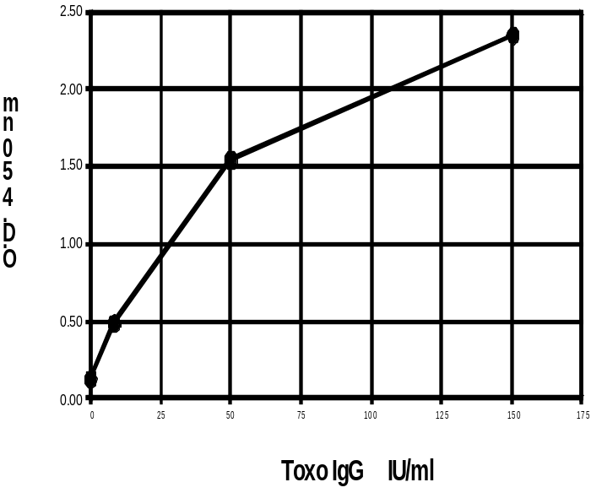

INTERPRETATION OF THE RESULT

IgG Index Value | Result | Interpretation
IgG Index  value <0.90 | Negative | Indicates absence of prior exposure to Toxoplasma (< 7IU/ml)
IgG Index value 0.91-0.99 | Grey zone | Sample should be retested  (7-8 IU/ml)
IgG Index value >1.0 | Positive | Indicates prior exposure to Toxoplasma virus (> 8IU/ml)

PERFORMANCE CHARACTERISTICS
A total of 100 patient samples were used to evaluate specificity and sensitivity of the test. TOXO IgG test results were compared to a commercial ELISA kit results:

 |  | Reference ELISA
 |  | N E P | Total
TOXO IgG ELISA | N  E  P | 56 (D) 0 2 (B)  0 0 0  0(C) 0 30(A) | 58  0  30
TOXO IgG ELISA | Total | 56 0 32 | 88

Sensitivity = 94%
Specificity = 100%
Accuracy= 98%

IMPORTANT NOTE
- This assay is a temperature sensitive assay. The best temperature condition for this assay is 37°C.
- The wash procedure is critical. Insufficient washing will result in poor precision and falsely elevated absorbance readings.
- It is recommended to use the multi channel pipettes to avoid time effect. A full plate of 96 wells may be used if automated pipetting is available.
- Duplication of Calibrators, controls & samples is not mandatory but may provide information on reproducibility & application errors.

LIMITATIONS OF THE ASSAY
- Lipemic, hemolyzed, icteric or heat inactivated sera may cause erroneous results.
- Toxoplasma antibody is present in apparently normal subjects in certain populations or geographic groups. A single test is not diagnostic for an active infection. Obtain two specimens at an interval of two weeks and test them at the same time to give more meaningful information.
- As with other serological assays, the results of these assays should be used in conjunction with information available from clinical evaluation and other diagnostic procedures.

BIBLIOGRAPHY
- Turune, H.J., P.O. Leinikke, and K. M. Saari. Demonstration of Intraocular Synthesis of Immunoglobulin G Toxoplasma Antibodies for Specific diagnosis of Toxoplasmic Chorioretinitis by Enzyme Immunoassay. J. Clin. Microbiol. 17:988-992, 1983.
- Lin, T.M., S.P. Halbert and G.R. O'Connor. Standardized Quantitative Enzyme-linked Immunoassay for Antibodies to Toxoplasma Gondii. J. Clin. Microbiol. Vol.11, 6:675-681, 1980.
- Roller, A., A. Bartlett and D.E. Bidwell. Enzyme Immunoassay with Special Reference ELISA Technique. J. Clin. Path. 31:507-520, 1987.
- Voller, A., D.E. Bidwell, A. Bartlett, D.G. Flick, M. Perkins and B. Oladshin. A Microplate Enzyme-immunoassay for Toxoplasma Antibodies. J. Clin. Path. 29:150-153, 1976
- Data on file: Orchid Biomedical Systems (P) Ltd.





